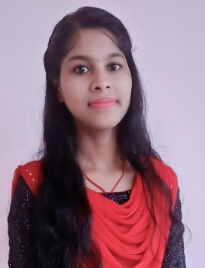Anita Mohanta

**D/O-Arjun Mohanta**

**At-Kuduma,**

**Po-Rasamatala,**

**Ps-Karanjia**

**Dist-Mayurbhanj(Odisha)**

**Pin-757037**

**Contact no: - +91 8763684874**

**E-mail:- anitamohanta382@gmail.com**

# CAREER OBJECTIVE

**To secure a challenging position as a software engineer in a reputed organization where I can apply my knowledge of programming languages, data structures, algorithms, and software development methodologies to create innovative solutions for real-world problems.**

# EDUCATION QUALIFICATION

* **Passed HSC from Radharaman Sikshya Niketan, Deobandha under B.S.E. Odisha in 2018 with 69 percentage.**
* **Passed +2 Science, from Similipal Science Res H.S. School, Karanjia , under CHSE, Odisha in the year 2020 with 52.33 percentage.**
* **Continuing B.Tech in Computer Science and Engineering from Nalanda Institute of Technology, Bhubaneswar under BPUT, Odisha**

# SKILLS

* **C**
* **HTML & CSS**
* **JAVASCRIPT**
* **BOOTSTRAP**
* **JAVA**
* **PYTHON**
* **GIT / GIT HUB**

# STRENGTH

* **Punctuality and time Management**.
* **Confident, Sincere & Hard Working.**
* **Dedication towards work.**
* **Work effectively in a team or individually**

# PERSONAL PROFILE

**Date of Birth : 08th March 2003**

**Gender : Female**

**Marital Status : Unmarried**

**Nationality : Indian**

**Religion : Hindu**

**Father’s Name : Mr. Arjun Mohanta**

**Mother’s Name : Mrs. Muktamani Mohanta**

**Communication Languages : English, Hindi, & Oriya**

# DECLARATION

**I do hereby declare that all my information stated in this Curriculum Vitae is true to the best of my knowledge and belief till date. I also understand that any discrepancy found. In any of the above statement render me liable for cancellation of candidature/ debarment/ appointment at any stage.**

**Place:**

**Date:**   **Signature of Candidate**